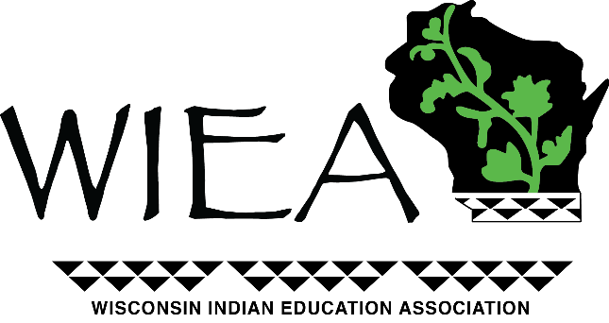

Fostering Teamwork and Collaboration

YOUTH DAY
Friday, April 26, 2024

*DRAFT AGENDA*

8:00-8:15 Registration & Breakfast at LDF Youth Center

8:15- 8:30 Welcome & Opening

8:30-10:00 Education Presentation/Activity
- Lac Courte Oreilles Ojibwe University
- College of Menominee Nation

10:00-11:00 Keynote Speaker:

- Scott Griffins

11:00-11:30 Lunch

11:30-2:30 Culture Presentation/Activity
- Spring Spearing
- Maple Syrup

2:30 Dismissal

